

**Name: Aqsa Essa**

**Section: Sec 4**

**Tableau Public Profile:** [**https://public.tableau.com/app/profile/aqsa.essa/vizzes**](https://public.tableau.com/app/profile/aqsa.essa/vizzes)

**Project Report**

**Project Title: Superstore Dataset Analysis Dashboard**

**Dataset Overview**

I am working with a dataset that contains 10000 rows and 22 columns. Key columns include:

* **Category**
* **City**
* **Country/ region**
* **Customer ID**
* **Customer Name**
* **Discount**
* **Order date**
* **Order ID**
* **Product ID**
* **Product Name**
* **Profit**
* **Quantity**
* **Region**
* **Row ID**
* **Sales**
* **Segment**
* **Ship date**
* **Ship mode**
* **State**
* **Sub-category**

**Worksheet 1: Total Sales by Categories**

The image shows a bar chart created in Tableau, displaying Category Sales across three different categories: Technology, Furniture, and Office Supplies. The data comes from a sample dataset titled "Orders (Sample Superstore)" and includes various tables such as Category, City, Country/Region, Customer ID, Product Name, and more**.**

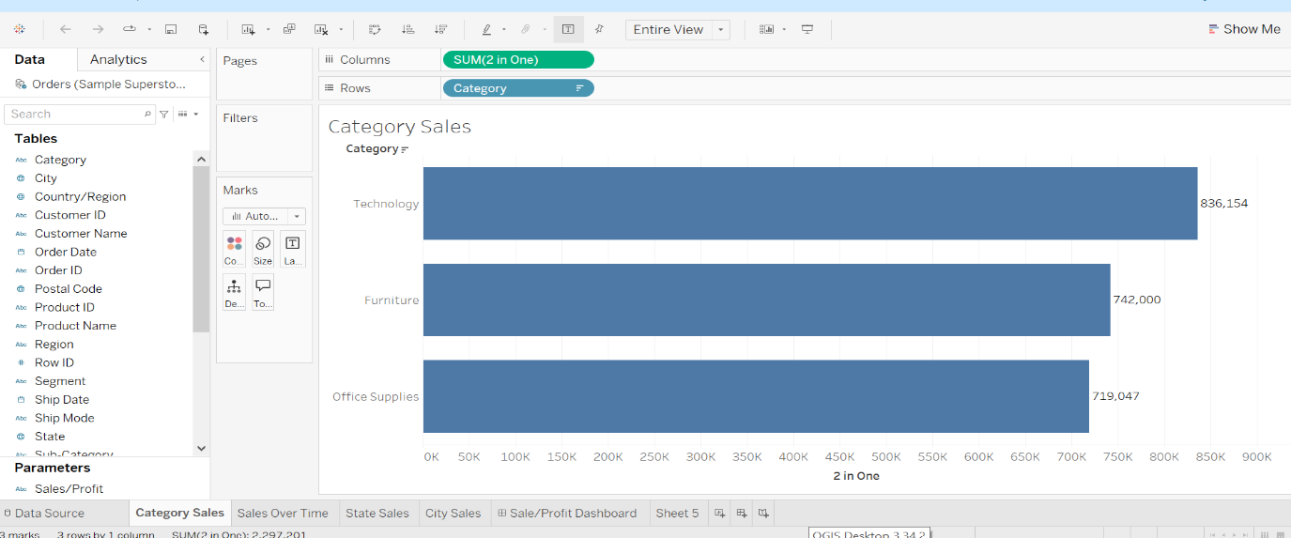

The chart uses SUM(2 in One) for the columns, which likely represents the total sales aggregated for each category. Each bar is visually distinct, with labels showing exact sales figures, aiding easy comparison.

This visualization helps identify which product categories are generating the most revenue, useful for further decision-making in areas like inventory management or marketing.

**Worksheet 2: Sales Over Time**

The image shows a line chart created in Tableau that tracks **Sales Over Time**. The data comes from the "Orders (Sample Superstore)" dataset, and the chart focuses on analyzing sales trends over multiple years.

**Key Components:**

* The x-axis represents the **months of the year** (from January to December).
* The y-axis represents the **total sales** (in dollars).
* The lines in the chart represent **different years**, with distinct colors:
  + **2016** (blue),
  + **2017** (orange),
  + **2018** (red),
  + **2019** (green).

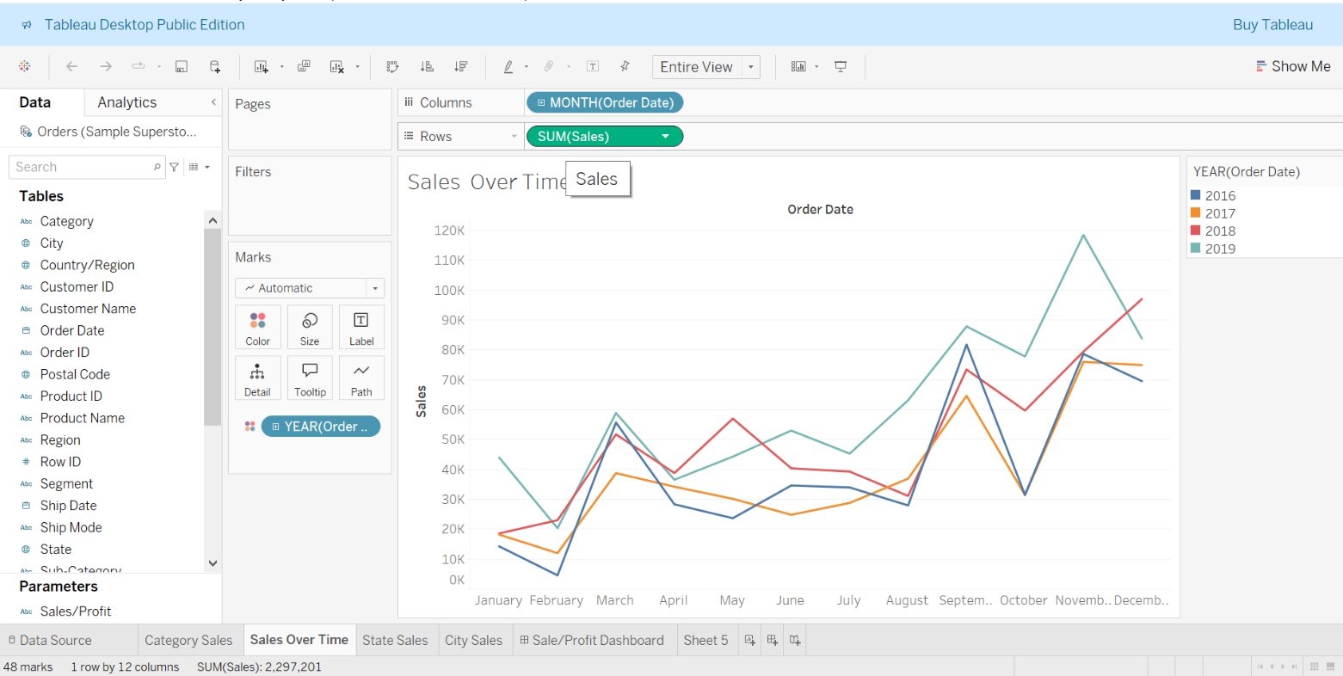

**Key Insights:**

* **Sales spikes** are observed around **March** and **December**, indicating higher sales during these periods across all years.
* There is an upward trend in sales for the year **2019**, particularly noticeable from **March** onwards, reaching its peak towards the end of the year.
* **2018** saw high sales in the middle of the year (around June), but later dropped compared to 2019.

This visualization helps in understanding **seasonal trends** and comparing sales performance year-over-year, which is useful for forecasting, planning marketing campaigns, or managing inventory.

**Worksheet 3: Sales Over State**

The main feature in the image is a map of the United States, showing sales data across different states. The varying shades of blue represent different levels of sales, with darker shades indicating higher sales volumes.

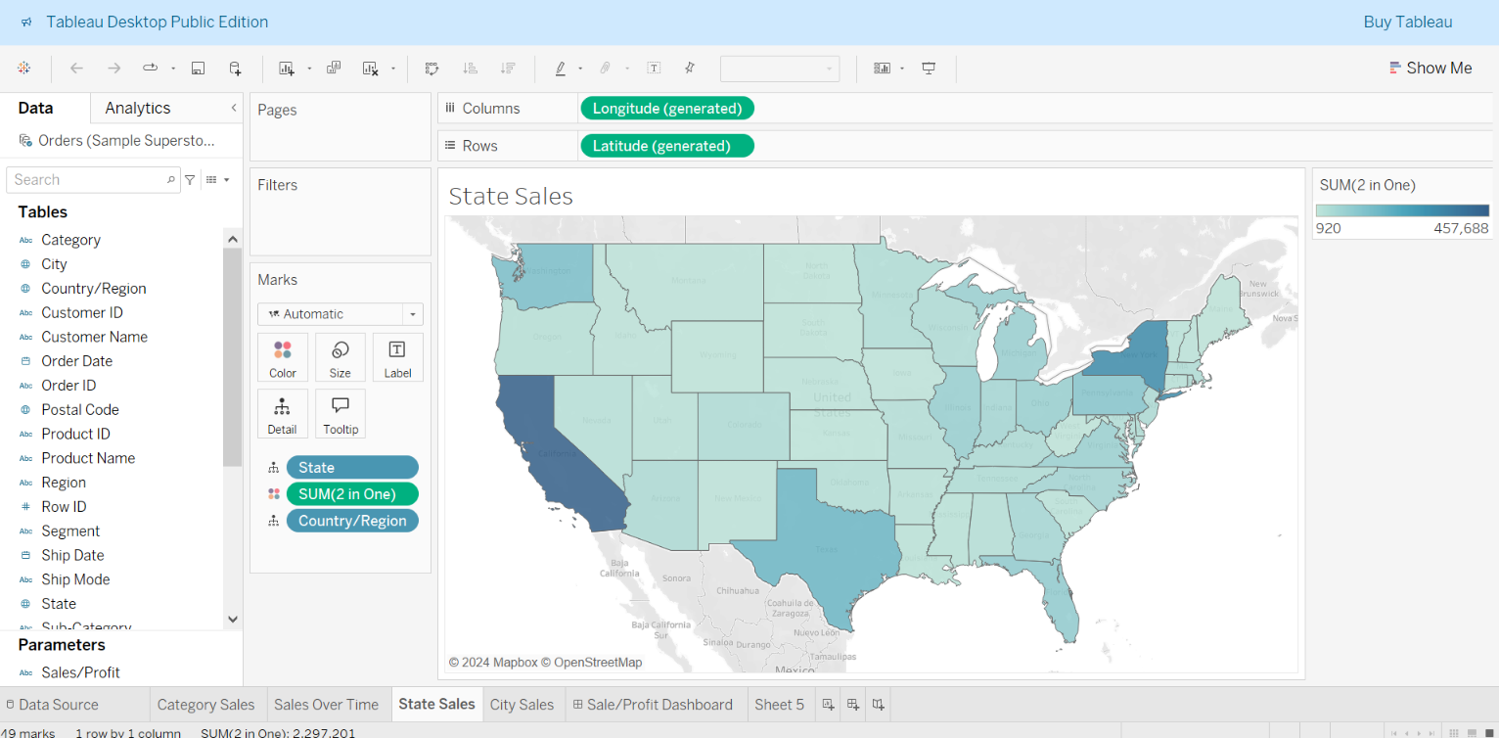

By analyzing the dashboard, users can potentially gain insights into the following areas:

* **Regional Sales Patterns:** Identify states with the highest and lowest sales volumes.
* **Product Performance:** Analyze sales trends for different product categories across different regions.
* **Customer Behavior:** Explore customer demographics and purchasing habits in various states.
* **Seasonal Variations:** Identify seasonal fluctuations in sales patterns

**Worksheet 4: Sales Over City**

The visualization utilizes a variety of dimensions, including city, state, region, product category, and customer information. These dimensions provide flexibility in exploring the data from different perspectives.

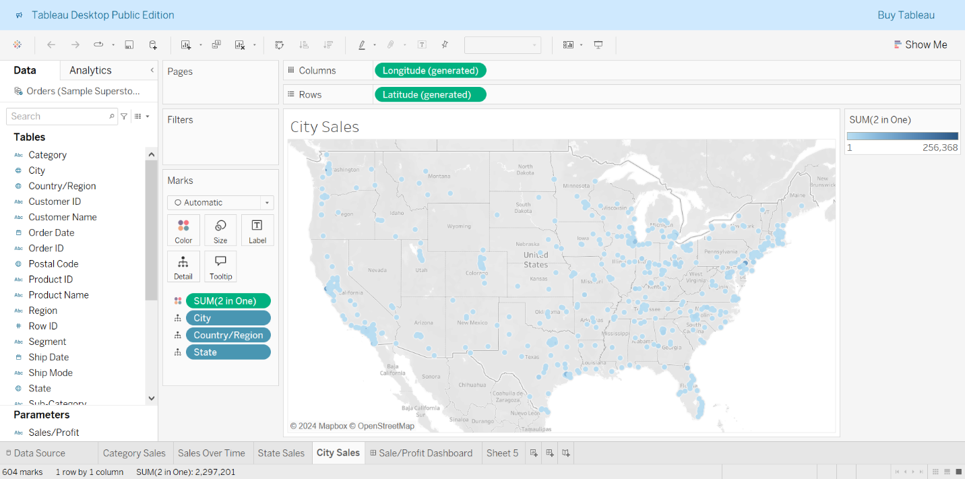

By analyzing the dashboard, users can potentially gain insights into the following areas:

* **City-Level Sales Trends:** Identify cities with the highest and lowest sales volumes.
* **Regional Sales Variations:** Compare sales performance across different regions and states.
* **Urban vs. Rural Sales:** Analyze differences in sales patterns between urban and rural areas.
* **Product Performance at the City Level:** Identify cities where specific product categories are particularly popular or underperforming.
* **Customer Behavior Analysis:** Explore customer demographics and purchasing habits in different cities.

**Dashboard Layout**

* **Goal**: Combine the charts into a comprehensive dashboard.

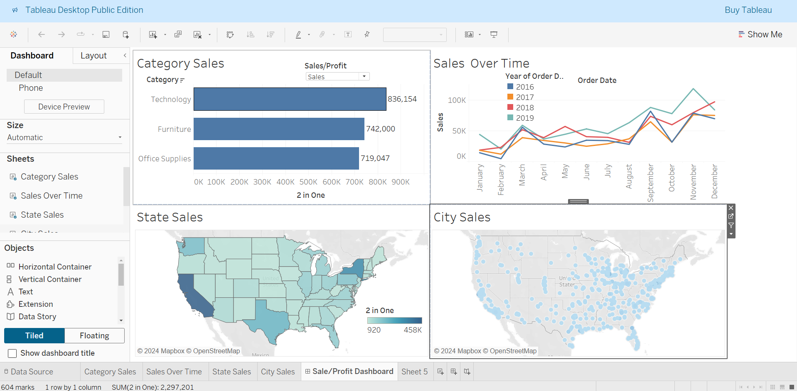

**Decision-Making Justification**

**Design Choices:**

Clarity: The use of a map to visualize sales data across states provides an intuitive and clear representation of geographical trends. The varying shades of blue make it easy to distinguish between different sales volumes.

Aesthetics: The color scheme is chosen to be visually appealing and easy on the eyes, ensuring that the dashboard is not only functional but also pleasant to look at. The consistent use of blue shades helps maintain a cohesive look.

Interactivity: Interactive features such as filters and drill-down options allow users to explore the data in more detail. This interactivity enhances user engagement and enables deeper insights.

**Challenges and Solutions**

**Challenges:**

Data Integration: Integrating data from multiple sources was challenging due to differences in data formats and structures.

Solution: Standardizing the data formats and using Tableau’s data blending features helped overcome this issue.

Performance: Handling large datasets caused performance issues, slowing down the dashboard.

Solution: Optimizing data extracts and using aggregated data for initial views improved performance significantly.

User Experience: Ensuring that the dashboard is user-friendly for both technical and non-technical users was a key challenge.

Solution: Conducting user testing and incorporating feedback helped refine the dashboard design to be more intuitive and accessible.

**Conclusion**

**Key Insights:**

Regional Sales Trends: The map visualization highlighted regions with high and low sales, providing valuable insights for targeted marketing and sales strategies.

Data Source Reliability: The “Sample - Superstore” dataset proved to be a reliable source for practice and demonstration, offering a comprehensive view of sales and profit metrics.

Interactive Analysis: The interactive features allowed for dynamic data exploration, enabling users to uncover deeper insights and make data-driven decisions.

**Impact on AI/ML Tasks:**

Feature Engineering: The insights from the EDA will inform the selection of relevant features for machine learning models, such as geographical location and sales volume.

Model Training: Understanding regional sales trends will help in training more accurate predictive models, as it provides context for the data.

Strategic Decisions: The EDA insights will guide strategic decisions in AI/ML projects, ensuring that models are aligned with business objectives and real-world trends.

**THE END**